Standard Operating Procedure for the Neocera Ex350 Pulsed Laser Deposition System at the CCMR Bard Materials Facility

Contents
Contents 1
Table of figures 2
Safety 2
A Bit About PLD 2
EX laser standard CT software (Laser Control Software) 3
Pulsed laser deposition system (System Control Software) 3
Manual Control Options: 3
Control Target Motors: 3
Substrate Rotation Motor 5
5
System Shutters 5
Laser and Laser Window Actuator 6
Heaters 6
Turbo control 8
MKS Gauges 8
Mass Flow Controls 8
Editors 9
Routine editor 9
Hold step 10
Wait for Base pressure 10
Laser Ablation 11
Heater 11
Looping routine editor 13
PLD Control Panel 13
Overview 13
Starting a routine 14
A last note 14

Table of figures
Figure 1: Control Target Motors 4
Figure 2: Control Substrate Motor 5
Figure 3: System Shutters 5
Figure 4: Control Laser 6
Figure 5: Heater Control 7
Figure 6: Turbopump Control 7
Figure 7: Mass Flow Controls 8
Figure 8: Hold Routine 10
Figure 9: Wait For Base Pressure 10
Figure 10: Laser Ablation 11
Figure 12: Heat Rate Table 12
Figure 11: Heater Step 12
Figure 13: Looping Routine Editor 13
Figure 14: PLD Control Panel 14

Safety
Notes about safety: this system uses a Class IV Krypton Fluoride excimer laser operating at 200 mJ. The wavelength for this laser is 248nm which is out of the visible range of your eye. Safety glasses are provided for your protection, please use them. Use of this tool requires that you take the EH&S laser safety course EHS 2397 before using the tool on your own. There are several emergency stop buttons that will prevent the laser from firing when activated. The red stop buttons are located on the laser near the optics box, on the wall to the right when facing the PLD computer, and in the foyer under the Fluorine alarm. They are labeled “Laser Stop” Pressing any of these buttons will disable the laser. This laser uses fluorine gas which is extremely hazardous. In the foyer, B47, there is a fluorine sensor with a pickup right above the laser table in B47B. This sensor is programmed to alarm and flash in the event of a fluorine leak. If a leak should occur, immediately remove yourself from room B47B to the foyer, room B47. If it is convenient please try and engage the laser interlock in the foyer. Once out please follow the instructions below and also posted under the alarm light in B47.

A Bit About PLD
The CCMR Pulsed Laser Deposition (PLD) system is a robust and versatile thin film deposition system that incorporates a 248nm Krypton Fluorine laser with a high vacuum chamber capable of holding multiple targets and substrates. The Laser is manufactured by GAM laser and the entire system is assembled by Neocera. The basic operating principles of the PLD system are thus: 248nm light from the KrF laser enters the chamber and strikes the target. Material from the target is ablated and travels in a direction that is normal to the target surface toward the substrate where the material condenses. The laser light is pulsed at a rate between 1 and 20 Hz with fluence values as high as 1.1J/cm². During ablation the target rasters back and forth under the laser light to ensure that the target will be ablated evenly.
Software
The main parts of the PLD system are the Laser, the optical assembly, and the vacuum chamber. There are two software packages that drive the laser and the vacuum chamber components, they are EX laser standard CT and Pulsed laser deposition system. They will be referred to as the laser control software and the system control software respectively. The laser control software is specifically for interfacing with the laser and will only be used briefly by the standard user of the system. The system control software will be used to interface with all parts of the system.

EX laser standard CT software (Laser Control Software)
Upon entry to the PLD room the user should first open up the laser control software and then turn on the power to the laser. The laser power is located in the back right corner of the laser and consists of a key and switch. To enable the laser power, turn the key clockwise and move the switch into the on position. There will be a soft beep. The laser control software should now show the laser status as on. The system requires a 5 minute warm up time, which should begin at this point. Much of the functionality of this software is handled in the system control but there are a few required selections to be made here. The first is that the laser needs to be placed into Continuous Operation. The second is that you need to select the control mode for the laser as constant energy or constant voltage and then select the desired energy or voltage level for the ablation. Lastly once the user is ready to fire the laser, and the laser has warmed up, they will need to return to this screen to start laser external trigger. Once these options are set the user should open the Pulsed laser deposition system software.

Pulsed laser deposition system (System Control Software)
This software will allow you to control all aspects of the PLD system to include: Target carousel motor and target rotation motors; Substrate rotation motors and CCS; Shutter; laser; Heaters; Turbo control and Mass flow control. It will also allow you to set up a routine editor that will greatly simplify multiple runs under the same conditions.

Manual Control Options:

Control Target Motors:
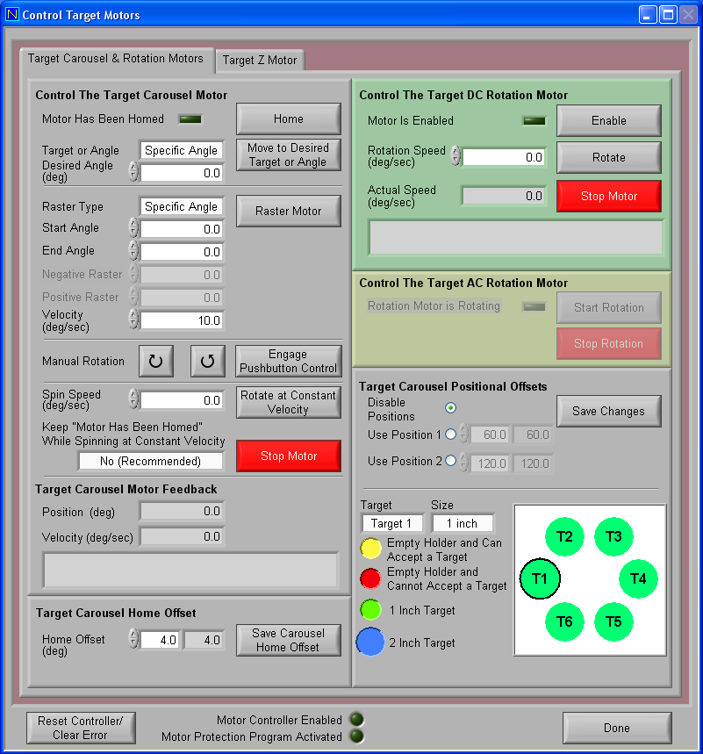
To begin open up the Pulsed laser deposition software. Move the mouse to the top menu bars and select the manual control. And then select the control target motor; the window in figure 1 will be displayed. First, the software will always require you to home the motors prior to using them. It is best to do this prior to placing your target or substrate in the holder so that you know that you are placing it in the home position. There are two options for target rotations: the carousel motor and the DC rotation motor. It is these two motors combined that create the rastering motion which allows the laser to evenly ablate the target. The rastering parameters are highly dependent on the rate of fire of the laser. One combination that I have found acceptable is:
Figure 1: Control Target Motors

Laser Fire Rate
10Hz

Target Carousel Motor
Raster type: specific angle
Start angle: 18°
End angle: -18°
Velocity: 10°/sec

Target Rotation Motor
20°/sec

The values for carousel and target rotation will need to be determined prior to creating your routine editor. Also in this menu you will see that there are options for manual rotation, spin speed and offsets. In general you should not need to access these options. In particular, the offset values have been optimized. Lastly you can see in the bottom right all of the targets on the carousel. The system has the ability to accept 6, 1” targets or 3, 2” targets. The user needs to specify the size of the target in any given position. This can be done by clicking on the target dropdown box and selecting the target that you would like to specify. Once the proper target is selected then you can select the proper size for that target. 1” targets will display as green and 2” targets will display as blue.
Figure 2: Control Substrate Motor

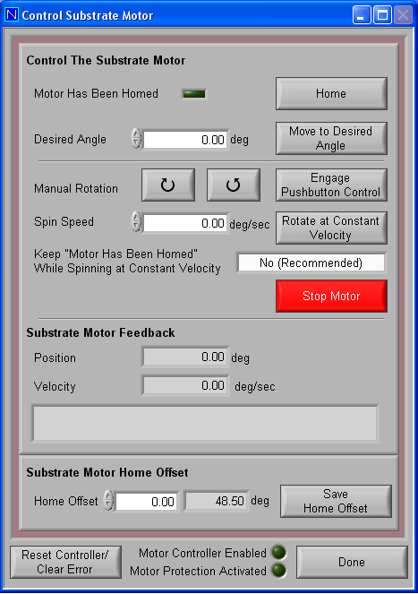
Substrate Rotation Motor
The substrate rotation motor dialogue can be seen in Figure 2. This motor is used to rotate the substrate during deposition to achieve a uniform distribution of target material on the substrate. The setting will be highly dependent on the rate of fire of your laser as well as the amount or material that is deposited per laser shot. As with all motors in this system the substrate rotation motor needs to be homed prior to its use. There are three options for the manual control: move to a specific angle, manual control, and rotate at constant velocity.

Figure 3: System Shutters
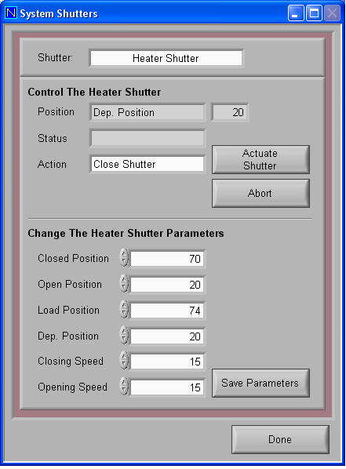

System Shutters
System shutter allows the user to open or close the system shutter to protect the substrate during pre-ablation. Open and closed positions should not be changed as it can swing the shutter into the laser path.

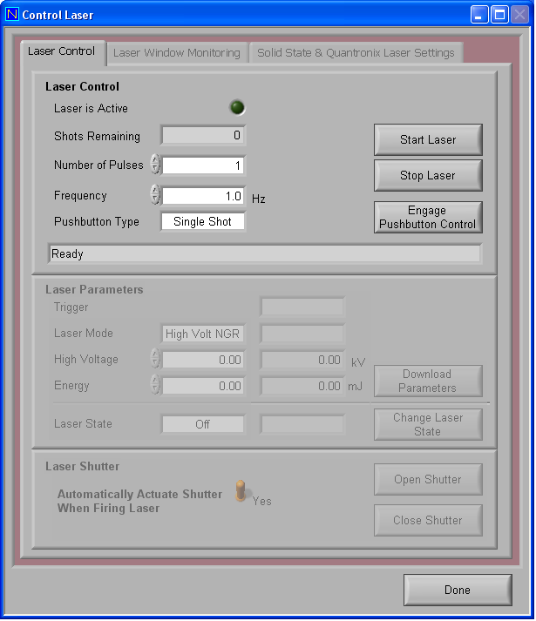
Laser and Laser Window Actuator
Figure 4: Control Laser
The only active tab in this GUI is the laser control tab. The laser can be controlled in two ways from this interface. The first is the start and stop laser buttons. When the start button is pushed the laser will begin firing the number of shots at the rate specified in the window. If the engage push button control is pressed the external pushbutton trigger becomes active and the laser can be fired externally. The pushbutton device will fire only a single shot.

Heaters
The heater consists of a resistive element on the backside of the substrate. In order to heat the substrate one needs to lower the heater into place after the substrate carrier and substrate have been placed in the system. When lowered the heater is approximately 1mm from the backside of the substrate. Maximum heater temperature is 1000°C. Due to the distance of the heater and the environment there is an approximately 18% drop in heat between the heater temperature and the substrate temperature. Maximum heater ramp rates are displayed in the chart below. Please be sure the rates are not exceeded. The heater must not be exposed to atmosphere at temperatures above 500°C. It should also be noted that the reset button should not be utilized above 300°C as this can cause the PID to go unstable. Due to this it is recommended that the heater is only controlled through the routine editors
Figure 5: Heater Control
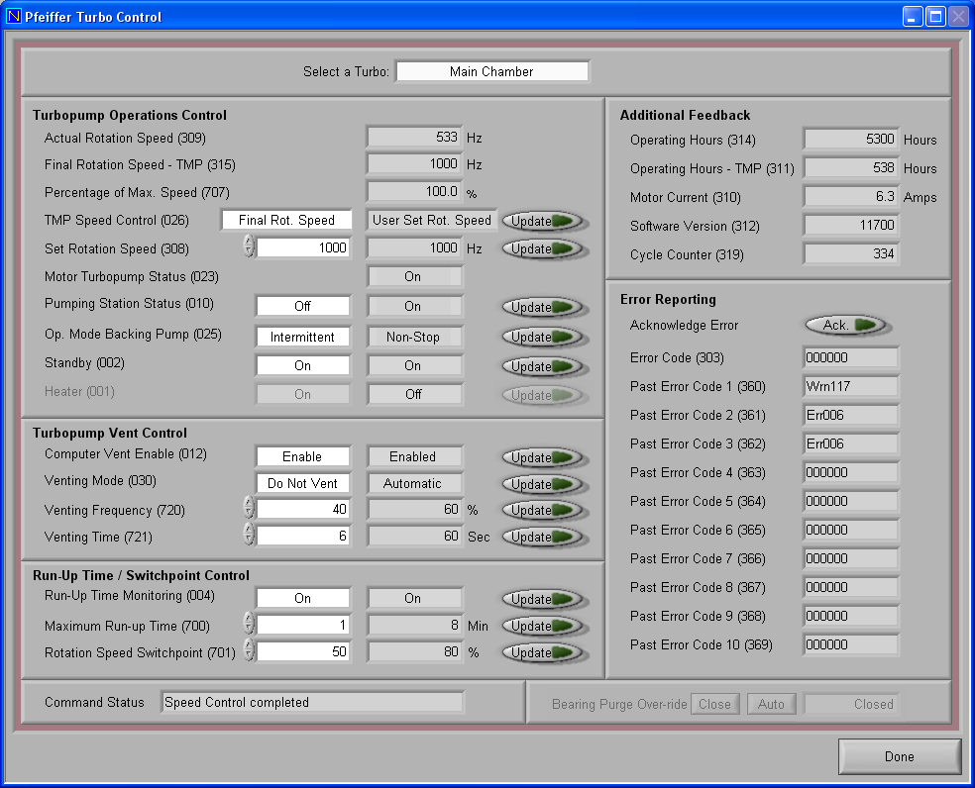
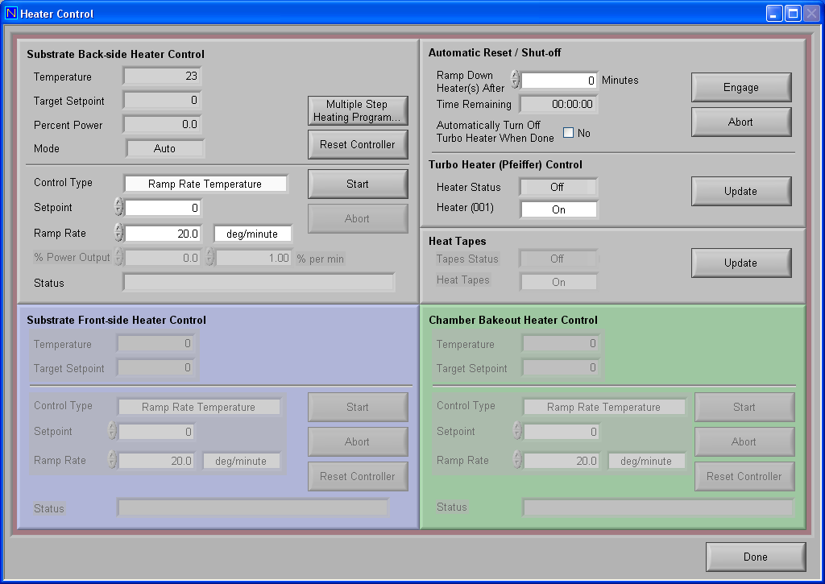
Figure 6: Turbopump Control

Turbo control
The Turbopump Control screen consists of three main sections: the Turbopump Operations Control; Turbopump Vent Control and the Run-Up Time/Switch Point Control. The user will only be interfacing with the Turbopump Operations Control section and settings in the Vent Control and Run-Up Time sections should be left alone. The operations control allows the operator to turn the turbopump on and off and set the rotation speed. The turbopump has a maximum rotation speed of 1000Hz and a minimum rotation speed of 250 Hz. When using mass flow control, turbo speed should be 500 Hz or less to avoid stressing the motor.

MKS Gauges
The settings on this screen should be left alone

Mass Flow Controls
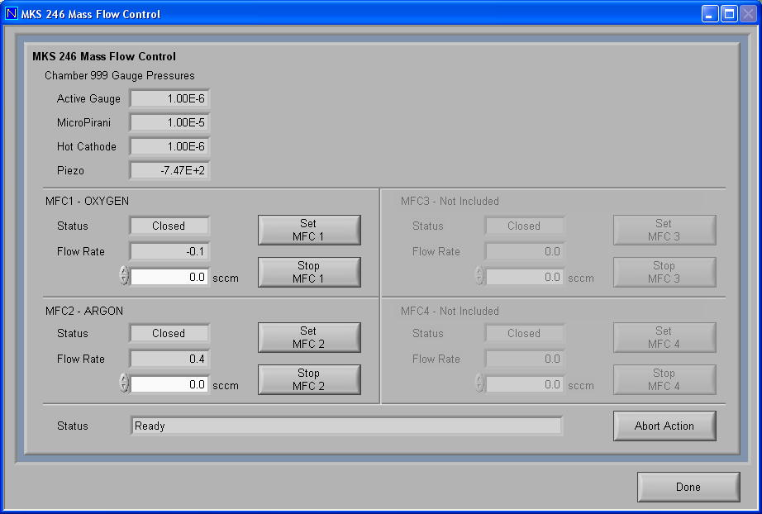
The mass flow controls are used in conjunction with the turbopump when you are interested in flowing gas through the vacuum chamber to maintain a refreshed deposition atmosphere. The proper flow rate and turbo speed needed to achieve your required pressure need to be determined prior to programming your routine editor. When flowing gas through the chamber the turbopump speed should be less than 500Hz and preferably 250Hz to avoid a tug of war between the Turbo and the flowing gas. To activate the mass flow controllers click on the white text box for controller 1 or 2 and enter the flow rate value that you want in Standard Cubic Centimeters per Minute. Then press the set MFC# button. Open the proper valve on the front panel for the gas that you will be flowing and finally open the fine flow valve on the side of the PLD to allow the gas to flow into the chamber.
Figure 7: Mass Flow Controls

Editors
The editors in the PLD control software allow the user the ability to establish a routine that is easily replicable. Establishing a routine can be done in 2 ways, either through the routine editor or through the looping routine editor. The routine editor is simpler to use if you have a simple routine. If your routine is complicated with lots of repeated steps then it is easier to use the looping routine editor. If using only the routine editor you will only need one .PLD file. If using the looping editor you will be required to create 2 files, an .LP file and a .PLD file. The .LP file is the extension for the looping routine editor and the .PLD file extension is the file type for the routine editor. In general a .LP file is made up of different steps that consist of .PLD files. Because of this, before you can make a .LP file you will need to make a .PLD file for each step in your deposition.

Routine editor
The routine editor is shown in Figure 7. Parameters for the routine editor differ depending on what routine type is selected in the step type box of the step information section of the GUI. The routine options are: hold, wait for base pressure, laser ablation and heater. The routine setups in these windows control all of the same functions as the manual controls described above. So, for example in the hold routine pictured, it is possible to make adjustments to the motor velocities, volume flow rate, turbo speed and system shutters. A hold routine can also be used to make manual adjustments to the system during your deposition. For example if you are interested in having static gas pressure in the chamber rather than flow through you can use this routine to hold the run so that the gate valve can be manually shut and the pressure bumped to the desired level. Routines can contain multiple steps as well but depending on the complexity of your deposition it may be easiest to keep the routine to 1 step and utilize the looping routine editor. The advantage to setting up routines in the routine editor is for automation. Once the steps have been created they can be assembled in a sequence so that the deposition will progress automatically.

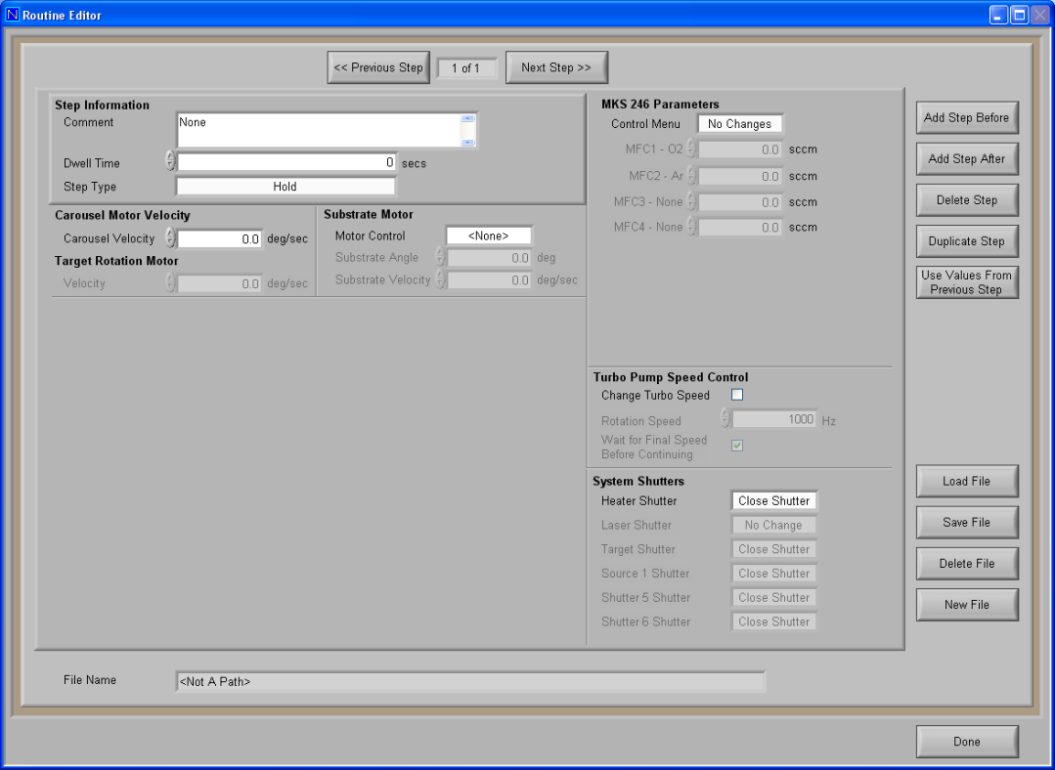
Hold step
Figure 8: Hold Routine
The hold routine will hold the deposition until the user prompts it to progress. This allows the user time to manually adjust settings or inspect the functioning of the chamber.

Wait for Base pressure
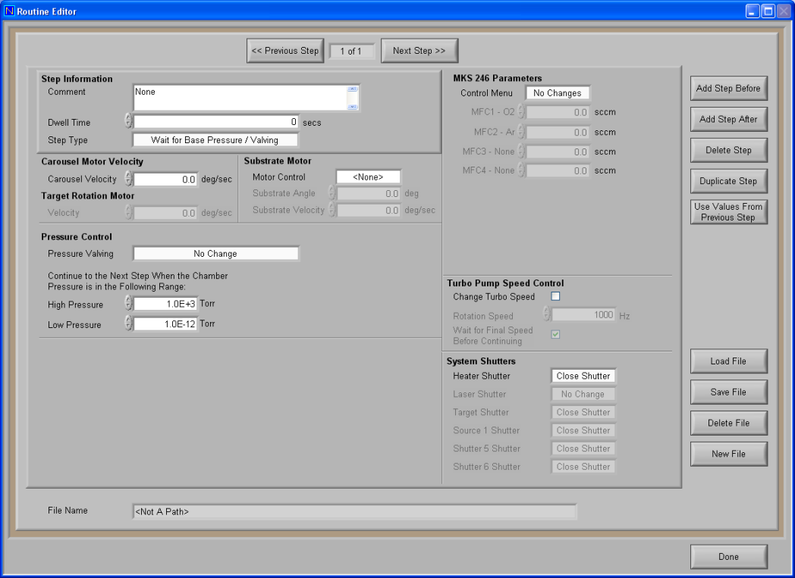
This step allows the user to wait for a certain base pressure before proceeding to the next step. Sometimes it may take the turbopump several minutes to spool down from high speed to the flow-through speed. It is also possible to adjust all of the parameter in the hold routine here.
Figure 9: Wait For Base Pressure

Laser Ablation
The laser ablation editor adds two different controls -- Target Carousel Motor and Laser – that will allow the user to adjust the target raster parameters and the laser firing parameters. This routine will be used for target pre-ablation and ablation.
Figure 10: Laser Ablation
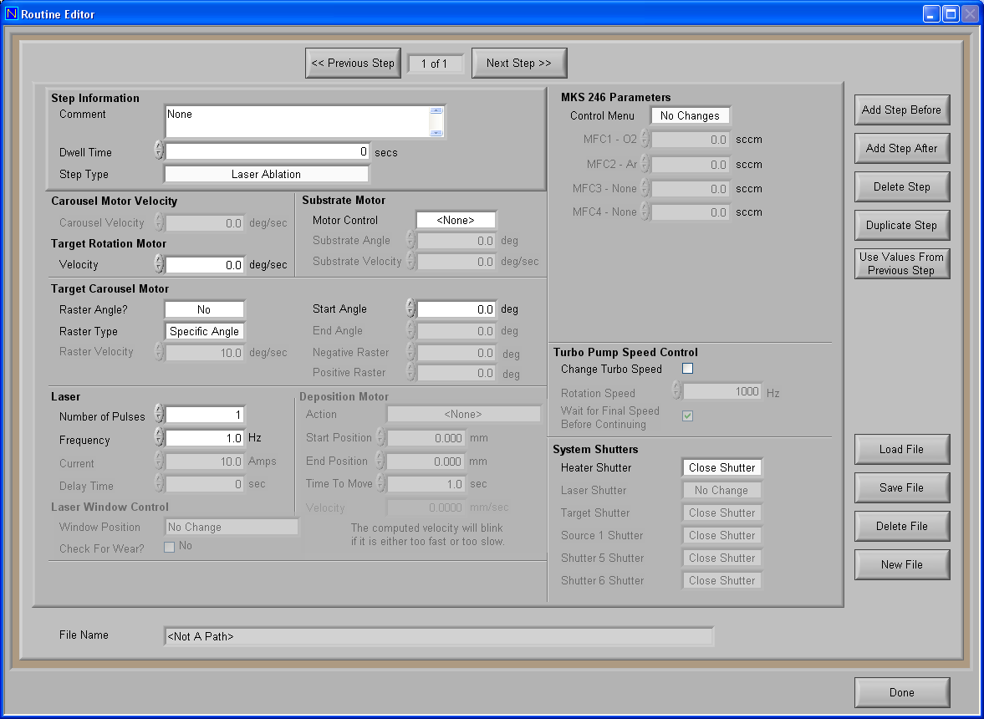

Heater
There are some precautions that need to be taken with the heater.
- Do not drive the heater above 1000°C.
- Do not set the heater ramp rate above the rates on the rate table in Figure 12.
- The heater should never be exposed to atmosphere while at temperatures above 500°C.
- Use extreme caution when using the reset function of the heater. If the heater is reset when it is at temperatures above 400°C and then restarted it can drive the PID unstable and cause an uncontrolled heating rate.
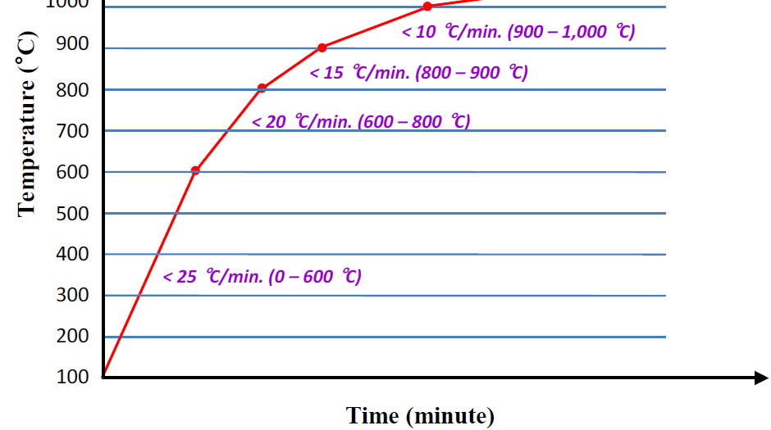
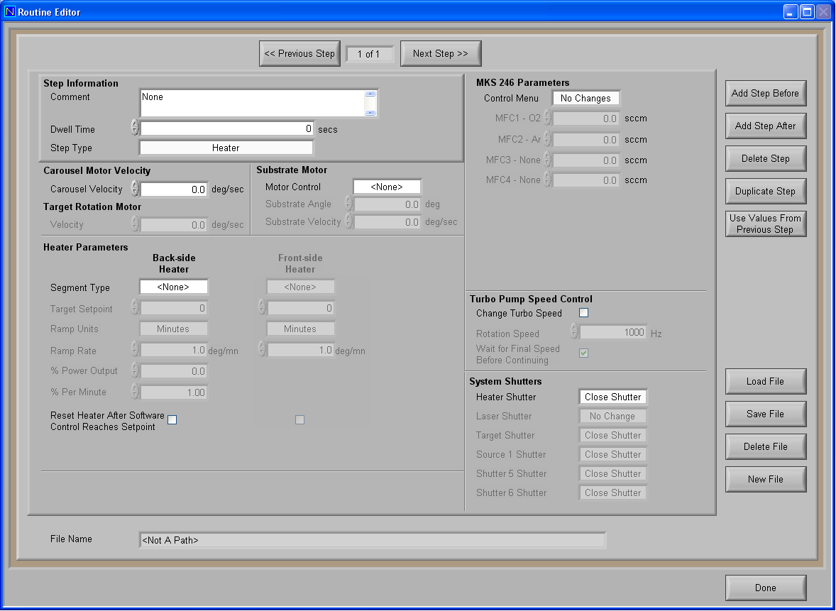
The heater step will allow you to drive the heater to your desired temperature. The heater parameters will only allow you to specify a ramp and set point. If you wish to dwell at your set point you need to specify the dwell time in the step information section. The heater will stay at the set point temperature until another heater routine is specified. This means that if you are interested in performing your deposition at elevated temperature than you will have a positive heating ramp step, a laser ablation step and a negative heating ramp step.
Figure 112: Heat Rate Table
Figure 121: Heater Step

Looping routine editor
The looping routine editor is convenient for performing more complex depositions which may involve switching between multiple targets hundreds of times. The looping routine editor will allow you to use multiple routines in a sequence to achieve a more complicated deposition without having to program repeated steps. To add files to the looping routine editor Highlight the line that you wish to edit and select edit line and find and select the required .PLD file to insert. Lines can be executed a number of times and the program can be looped to other lines for repeating segments.
Figure 13: Looping Routine Editor
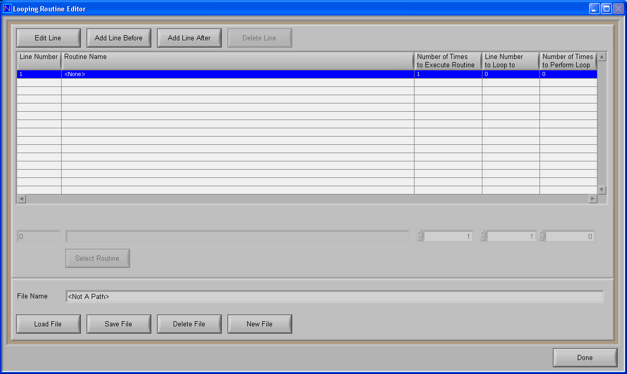

PLD Control Panel

Overview
The PLD/PED Control panel is where the user will load the routine for their deposition. The routine includes all of the parameters for the deposition and it will help the user to maintain continuity across depositions with similar parameters. Users can load either .PLD or .LP files. This window will allow the user access to information about the system including heater temp, turbo speed, laser shots remaining, and motor homing.
Figure 14: PLD Control Panel
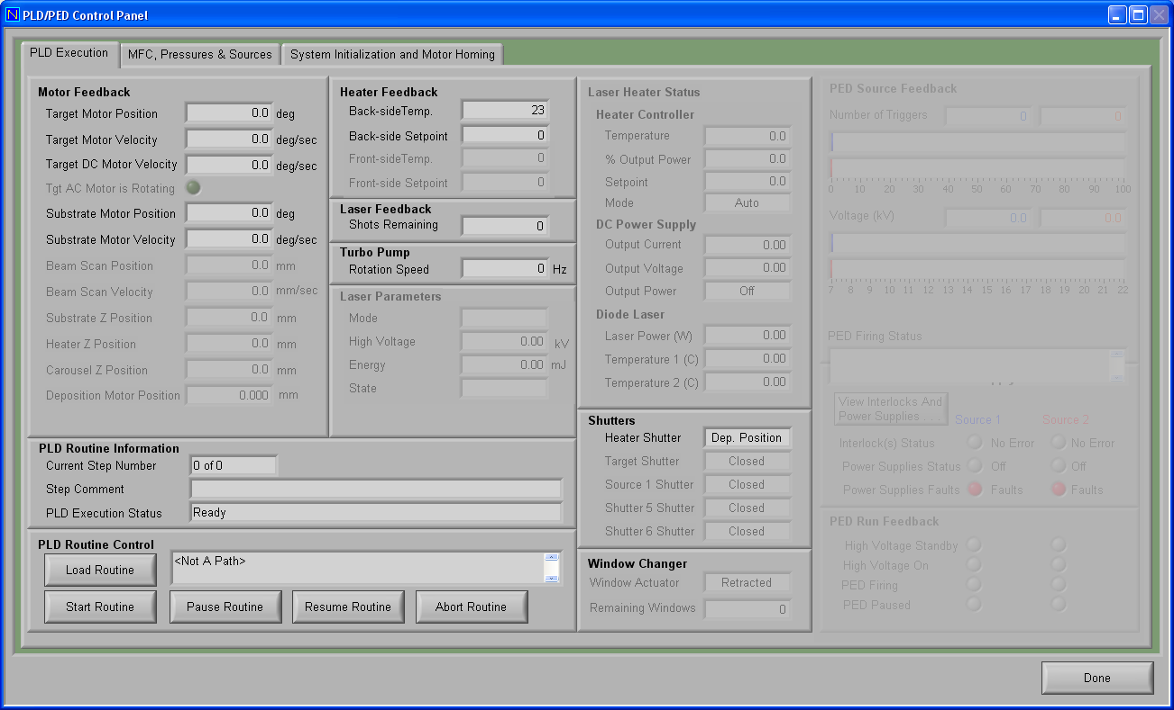

Starting a routine
Once the .PLD or .LP files have been loaded into the control panel and all system motors have been homed the routine is ready to start. Prior to starting a routine please ensure that the chamber is in the correct starting configuration; for example if you are starting the turbo pump ensure that the gate valve is open and the chamber vent valves are closed. Once you are sure that everything is in the correct order the routine can be started by pressing the “Start Routine” button.

A last note
From the manual for the Imahashi faceting tool: “Do not blame the machine for your own mistakes. The machine will do only what you make it do. You will learn through your mistakes, seldom through your successes.” Good advice to follow!

